Gracious
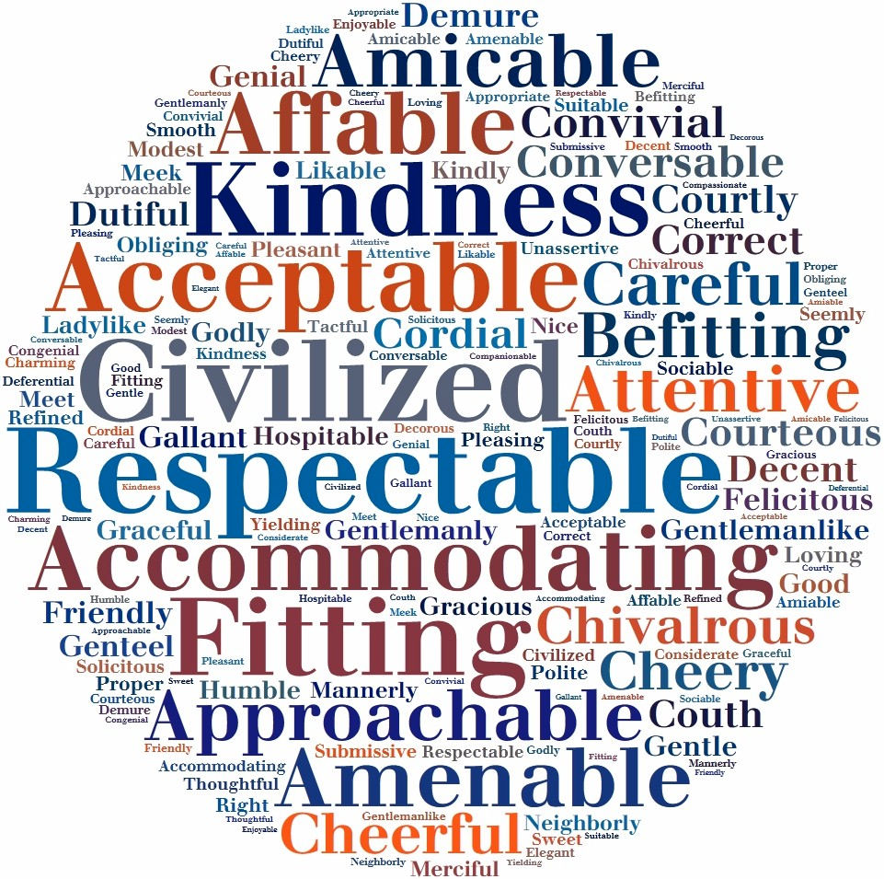
Acceptable Accommodating Affable Amenable Amiable Amicable Approachable Appropriate Attentive Becoming Befitting Careful Charming Cheerful Cheery Chivalrous Civil Civilized Companionable Compassionate Congenial Considerate Conversable Convivial Cordial Correct Courteous Courtly Couth Decent Decorous Deferential Demure Dutiful Elegant Enjoyable Felicitous Fit Fitting Friendly Gallant Genial Genteel Gentle Gentlemanlike Gentlemanly Godly Good Graceful Gracious Hospitable Humble Kind Kindly Kindness Ladylike Likable Loving Mannerly Meek Meet Merciful Modest Neighborly Nice Obliging Pleasant Pleasing Polite Proper Refined Respect Respectable Respectful Right Seemly Smooth Sociable Solicitous Submissive Suitable Sweet Tactful Thoughtful Unassertive Yielding

Ungracious
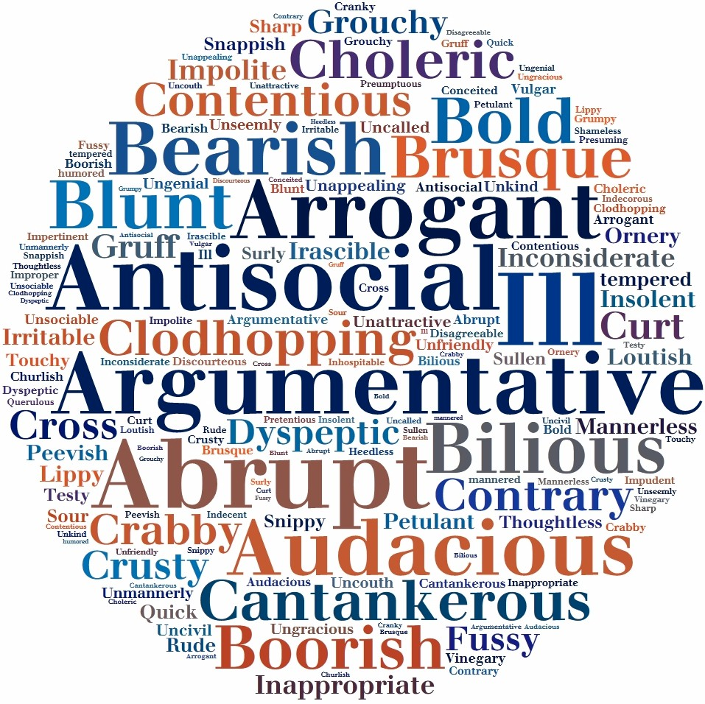
Abrupt Antisocial Argumentative Arrogant Audacious Bearish Bilious Blunt Bold Boorish Brusque Cantankerous Choleric Churlish Clodhopping Conceited Contentious Contrary Crabby Cranky Cross Crusty Curt Disagreeable Discourteous Dyspeptic Fussy Grouchy Gruff Grumpy Heedless Ill-humored Ill-mannered Impertinent Impolite Improper Impudent Inappropriate Inconsiderate Indecent Indecorous Inhospitable Insolent Irascible Irritable Lippy Loutish Mannerless Ornery Peevish Petulant Presuming Pretentious Preumptuous Querulous Quick-tempered Rude Shameless Sharp Snappish Snippy Sour Sullen Surly Testy Thoughtless Touchy Unappealing Unattractive Uncalled-for Uncivil Uncouth Unfriendly Ungenial Ungracious Unkind Unmannerly Unseemly Unsociable Vinegary Vulgar

